15.JPG NUMBER SQUARE

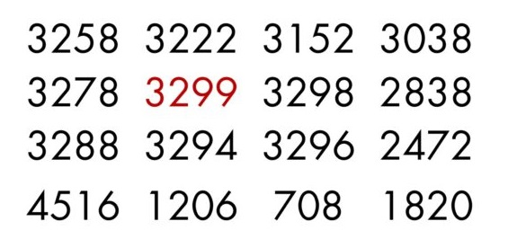

This number square is mathematically interpretable through various methods:

**1.** [Recurrence Relation](https://www.3301archive.com/15-jpg-number-square-recurrence-relation/)

**2.** [Zeckendorf’s Theorem](https://www.3301archive.com/15-jpg-number-square-zeckendorf/)

**\****The image(s) featured on this page are scaled. For unmodified 3301 images and materials, download the*[*Asset Pack*](https://www.3301archive.com/assets/)*.*

15.JPG NUMBER SQUARE RECURRENCE RELATION

15.jpg Number Square

**Abstract:**  
The [Number Square](https://www.3301archive.com/15-jpg-number-square/)featured in [15.jpg](https://www.3301archive.com/15-jpg/) is interpretable as a  
Prime-Order [Recurrence Relation](https://en.wikipedia.org/wiki/Recurrence_relation) value array of the form

*F(x+1) = f(x) + f(x-1*)

~~~ **Section 1 / 4: Terminology** ~~~

*Consider, if you will, the mathematical set of all prime numbers.*

This can be represented as:  
  
**{2, 3, 5, 7, 11, 13, 17, 19, 23, 29, 31 …}**  
  
Now, pick any number in this set.  
Call your chosen prime’s position in the above set its **‘order’**.  
  
**Set the number ‘2’ as order 0**, such that 3 is order 1, 5 is order 2, etc.  
  
This ‘**Prime Order**‘ terminology can be written as**Pn**, where ‘**n**’ is the **order**of a particular prime and ‘**P**‘ just means ‘**Prime**‘.  
  
So, **the number 2 is written as P0, 3 is written as P1, 5 is written P2, and so on**. Moving forward, we will use this ‘Prime Order’ notation.

~~~ **Section 2 / 4: Initial Terms** ~~~

Now, consider **the given numerical values** of 15.jpg’s [Number Square](https://www.3301archive.com/15-jpg-number-square/) entries.  
Specifically, **consider these values as differenced from the number ‘3301’**.  
  
Direct your attention to the following given entry in the Number Square:

**3299**

**It is both the only red number and the *only prime number* of the table. It is also, numerically, 2 less than 3301.** Following this observation, we will now be labeling the entries of this Number Square according to their mathematical difference from 3301, in the ‘**Pn**’ Prime Order notation **discussed previously**. The red ‘**3299**‘ item serves as our **P0** starting point.

**~~~ Section 3 / 4: Process ~~~**

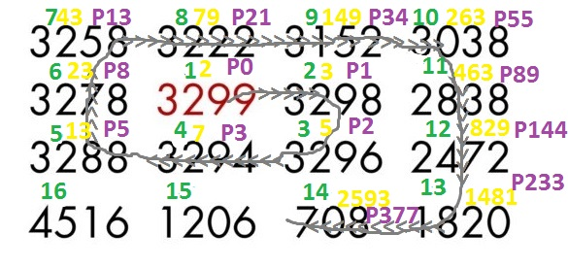15.jpg Recurrence Relation

**Key:**

Green ::: Number Square Entry Position

Gold ::: Entry Difference From Value 3301

Purple ::: Prime Order of [Entry Difference from 3301]

*Let’s Begin.*

**Label the glaring red starting point of 3299 as P0, since 3301-3299=2 and 2 = P0.**  
  
Now, direct your attention rightward one item in the table, from 3299 to 3298. Applying the same treatment as before, 3298 shall be labeled as P1, since 3301-3298 = 3, and 3 =P1. **So now we have P0 in the place of 3299 and P1 in place of 3298.**  
  
Move one item down from 3298 to 3296. Same treatment and 3296 becomes P2. Continue this process along the directional spiral in the above, modified image of 15.jpg’s number square, which is the raw table entries’ path of decreasing numerical value, and you end up with a Prime Order table that **Prime Order Recurrence Relation** whose first 14 entries take the form:  
  
**{0, 1 , 2, 3, 5, 8 , 13, 21, 34, 55, 89, 144, 233, 377…}**

**~~~ Section 4 / 4: Anomalous Completion ~~~**

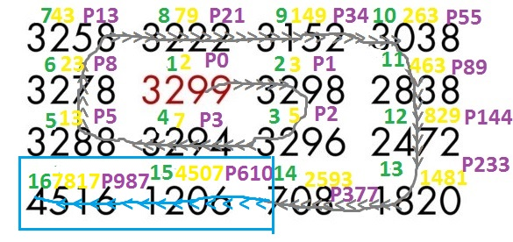

The **final two raw entries** of the original 15.jpg table diverge from the rest of the pattern:  
  
**1206** and **4516**  
  
To properly convert these two values to prime order values in the established manner and smoothly continue the recurrence relation sequence, one must switch from calculating each raw entry’s encoded prime by the format  
  
**[3301- (raw table entry) =? ]**  
to  
**[3301 + (raw table entry) = ? ]**  
  
to compute the prime order of the resultant value.  
Doing this perfectly extends the number square’s prime order recurrence relation by giving us the indicated primes **4507** and **7817**, and thus the prime order terms:  
  
**{…610, 987}**  
  
We are now left with the final converted Prime Order Recurrence Relation Sequence of 15.jpg’s Number Square:

**{0, 1, 2 ,3 ,5 ,8, 13, 21, 34, 55, 89, 144, 233, 377, 610, 987}**

*Q.E.D.*